**PIZZA SALES ANALYSIS**

BY Anas

Qadir Bux

Nasir

|  |  |  |  |  |  |  |  |
| --- | --- | --- | --- | --- | --- | --- | --- |
| **Spreadsheet tab** | **Element or value display name** | **Description** | **Data type** | **Character length** | **Acceptable values** | **Required?** | **Accepts null value?** |
| Orders | order_id | (Primary Key)Unique identifier for each order placed by a table | Integar | 255 | Only numbers | Yes | NO |
| Orders | date | Date the order was placed (entered into the system prior to cooking & serving) | Date | 8 | DD/MM/YYYY | Yes | Yes |
| Orders | time | Time the order was placed (entered into the system prior to cooking & serving) | Time | 6 | 0:00:00 | Yes | Yes |
| **Spreadsheet tab** | **Element or value display name** | **Description** | **Data type** | **Character length** | **Acceptable values** | **Required?** | **Accepts null value?** |
| Order Details | order_details_id | (Primary Key) Unique identifier for each pizza placed within each order (pizzas of the same type and size are kept in the same row, and the quantity increases) | Integar | 5 | Only numbers | Yes | NO |
| Order Details | order_id | Foreign key that ties the details in each order to the order itself | Integar | 5 | Only numbers | Yes | NO |
| Order Details | pizza_id | Foreign key that ties the pizza ordered to its details, like size and price | Varchar | 30 | Alphabets | Yes | NO |
| Order Details | quantity | Quantity ordered for each pizza of the same type and size | Integar | 1 | Only numbers | Yes | NO |

**DATA DICTIONARY:**

**DATA DICTIONARY: CONT’**

|  |  |  |  |  |  |  |  |
| --- | --- | --- | --- | --- | --- | --- | --- |
| **Spreadsheet tab** | **Element or value display name** | **Description** | **Data type** | **Character length** | **Acceptable values** | **Required?** | **Accepts null value?** |
| Pizzas | pizza_id | (Primary Key) Unique identifier for each pizza (constituted by its type and size) | Varchar | 255 | Alphanumeric characters | Yes | NO |
| Pizzas | pizza_types_id | Foreign key that ties each pizza to its broader pizza type | Varchar | 30 | Alphanumeric characters | Yes | NO |
| Pizzas | size | Size of the pizza (Small, Medium, Large, X Large, or XX Large) | Varchar | 3 | Alphabet | Yes | NO |
| Pizzas | price | Price of the pizza in USD | Decimals | 4 | USD with two decimals | Yes | NO |
| **Spreadsheet tab** | **Element or value display name** | **Description** | **Data type** | **Character length** | **Acceptable values** | **Required?** | **Accepts null value?** |
| Pizza Types | pizza_types_id | (Primary Key) Unique identifier for each pizza type | Varchar | 30 | Alphanumeric characters | Yes | NO |
| Pizza Types | name | Name of the pizza as shown in the menu | Varchar | 255 | Alphabets | Yes | NO |
| Pizza Types | category | Category that the pizza fall under in the menu (Classic, Chicken, Supreme, or Veggie) | Vachar | 10 | Alphabets | Yes | NO |
| Pizza Types | ingredients | Comma-delimited ingredients used in the pizza as shown in the menu (they all include Mozzarella Cheese, even if not specified; and they all include Tomato Sauce, unless another sauce is specified) | Varchar | 255 | Alphanumeric strings, special characters, and spaces | Yes | NO |

* **DATABASE FOLDER:** database link
* **OBJECTIVES:**
* To increase sales by identifying pizza types, category and peak hours
* To make inventory management efficient by identifying high selling pizzas, types, category and size
* To identify customer preferred pizza size
* To identify the relation between price and the sales of the pizza
* To identify customers preffered pizza category
* To identify seasonal trends
* **KEY PROBLEMS:**

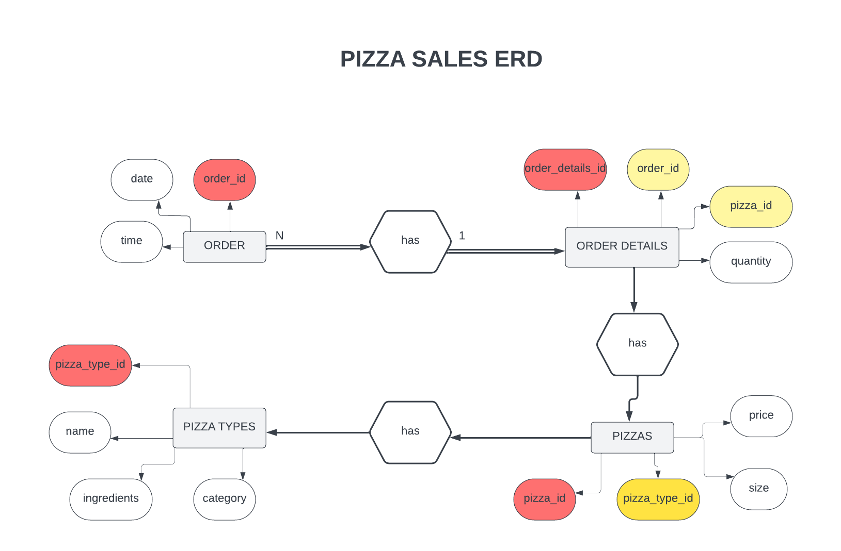

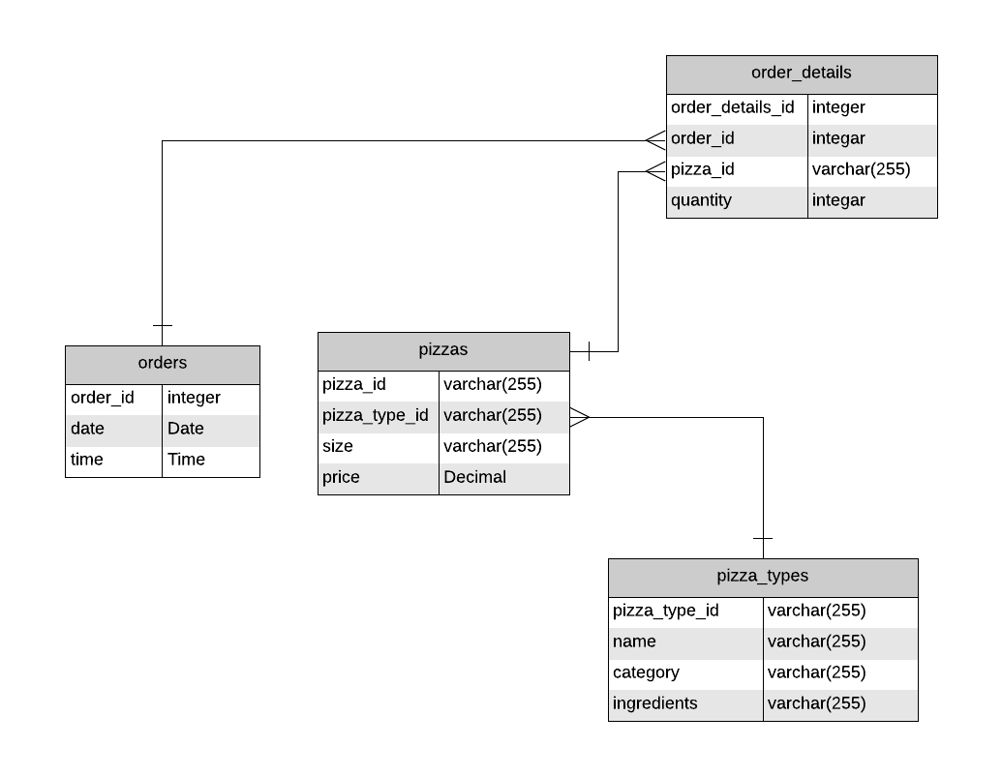

1. **Which pizza type has the highest overall sales revenue?**

Ans: This question can help identify the most popular pizza type contributing significantly to the business's revenue.

**Impact:** We can use this to create an offer using this pizza to increase sales of the slow-selling item

We can launch new flavors similar to the highest-selling one

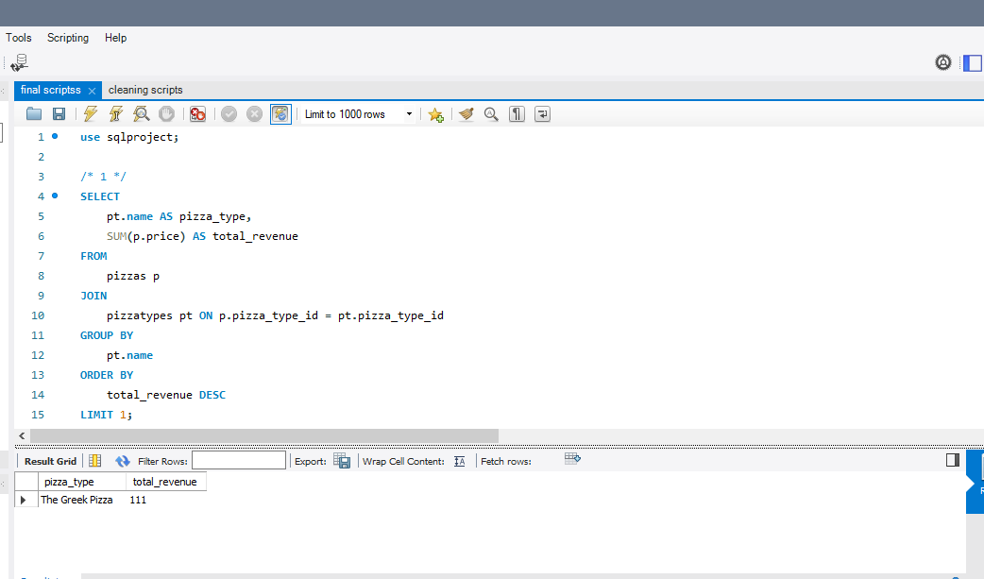

1. **What is the average order size (quantity of pizzas ordered & sales value) during peak hours?**

This question can help identify the quantity of pizza type, size, and flavors during peak hours which will help us to run operations eg efficiently. inventory

**Impact:** Analyzing the average order size during peak hours can guide decisions related to promotions or upselling strategies.

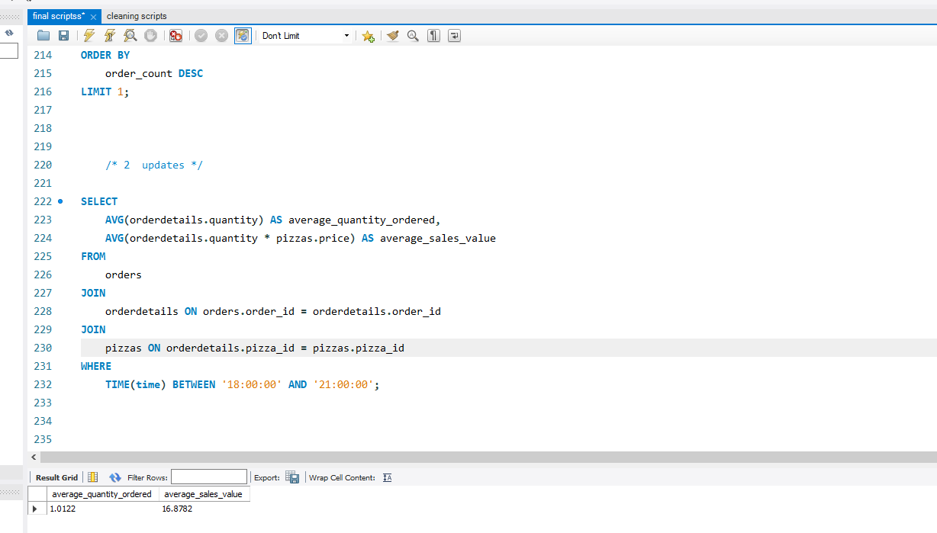

1. **are the top three pizza types ordered during Specific Times (weekends and weekdays etc)?**

Understanding weekend preferences can help tailor marketing efforts and promotions for specific days. This will help us to generate more sales revenue and help us identify that is there any difference in weekends and weekdays peak hours

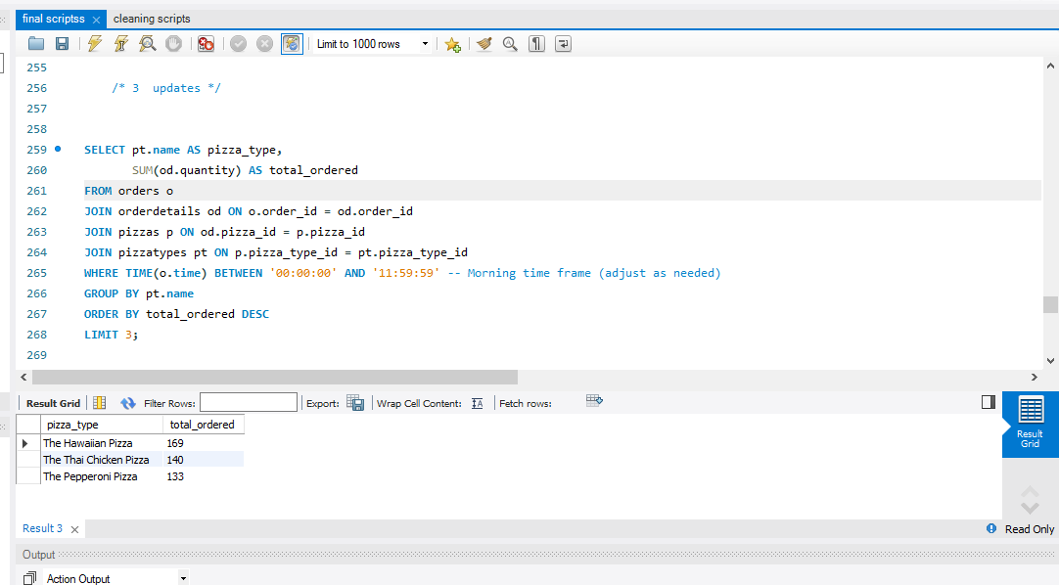

1. **Which pizza size is the most popular among customers ordering?**

Due to this we can get to know the highest selling size and we can get to know about our customers and target them accordingly

This can help optimize inventory management and highlight popular size choices.

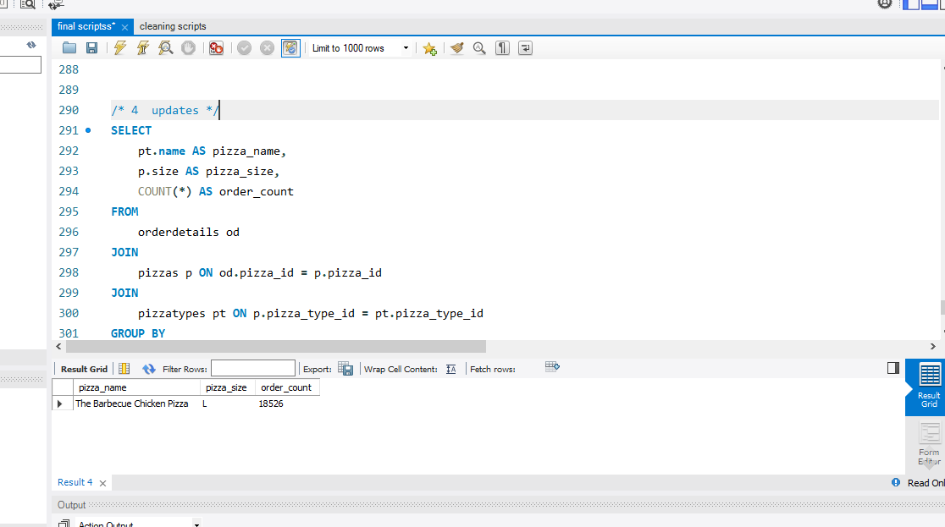

1. **Are there any specific pizza types that consistently increase orders over the past quarter?**

Identifying trends can aid in predicting customer preferences and ensuring sufficient stock for trending pizzas.

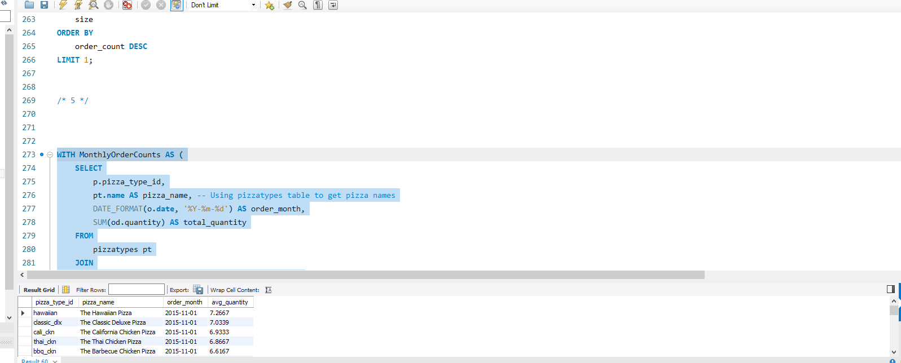

JOIN

pizzas p ON pt.pizza_type_id = p.pizza_type_id

JOIN

orderdetails od ON p.pizza_id = od.pizza_id

JOIN

orders o ON od.order_id = o.order_id

WHERE

o.date >= DATE_SUB("2015-12-01", INTERVAL 1 month) -- Data for the past quarter

GROUP BY

p.pizza_type_id, pt.name, order_month

),

AverageMonthlyOrderCounts AS (

SELECT

pizza_type_id,

pizza_name,

order_month,

AVG(total_quantity) AS avg_quantity

FROM

MonthlyOrderCounts

GROUP BY

pizza_type_id, pizza_name

)

SELECT

pizza_type_id,

pizza_name,

order_month,

avg_quantity

FROM

AverageMonthlyOrderCounts

ORDER BY

avg_quantity DESC;

**6. Do certain pizza types have higher average prices? How does this relate to their sales volume?**

Analyzing the relationship between price and sales volume can provide insights into customer preferences and willingness to pay and we can get to know that price or pizza types matters if price mattes then we can reduce our prices accordingly if not then improve pizza’s quality or introduce more types

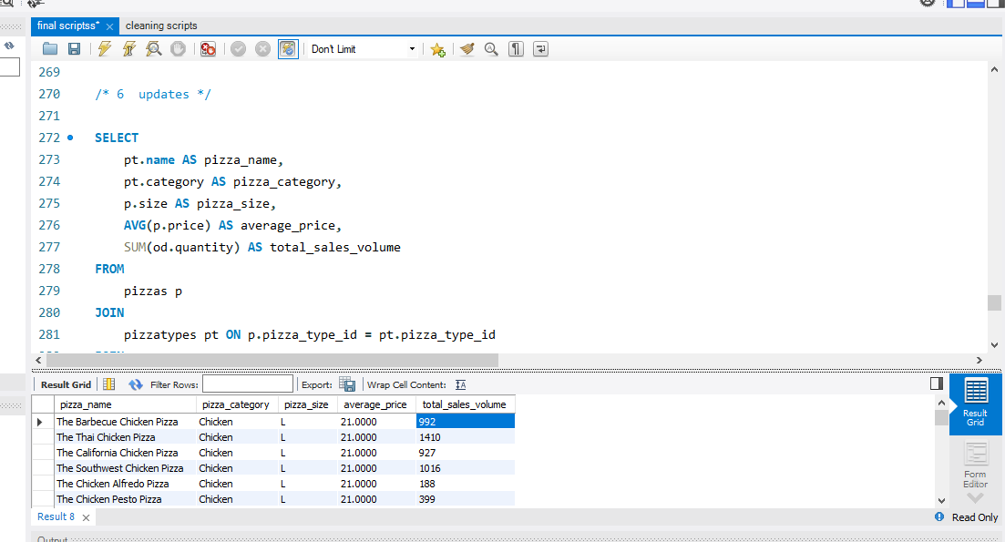

JOIN

pizzatypes pt ON p.pizza_type_id = pt.pizza_type_id

JOIN

orderdetails od ON p.pizza_id = od.pizza_id

GROUP BY

pt.name, pt.category, p.size

ORDER BY

pt.category, p.size;

**7. Which pizza category (Classic, Chicken, Supreme, Veggie) has the highest and lowest sales during lunch hours? during lunch hours? Can we skip this and**

Ans: this can help identify which category has highest and lowest sales due to which we can get to know our customer preferences better and expand the pizza types in the category which has highest sales and minimize efforts in lowest sales

This can help refine the menu or promotional offerings based on customer preferences at different times of the day.

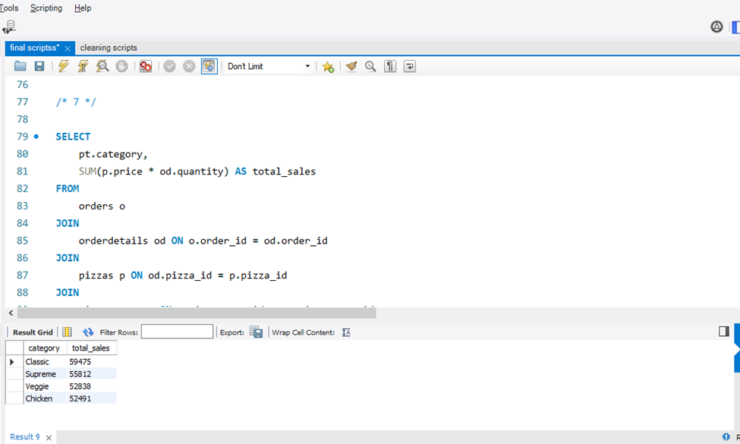

JOIN

pizzatypes pt ON p.pizza_type_id = pt.pizza_type_id

WHERE

TIME(o.time) BETWEEN '12:00:00' AND '14:00:00' -- Assuming lunch hours are between 12 PM and 2 PM

GROUP BY

pt.category

ORDER BY

total_sales DESC;

**8: How do the sales of vegetarian pizzas compare to non-vegetarian pizzas within each size category?**

In this we can identify what percentage customers prefers veg and non veg pizza and we can specifically target our customers according to their preferences

Understanding the preference for vegetarian options can guide menu adjustments and marketing strategies.

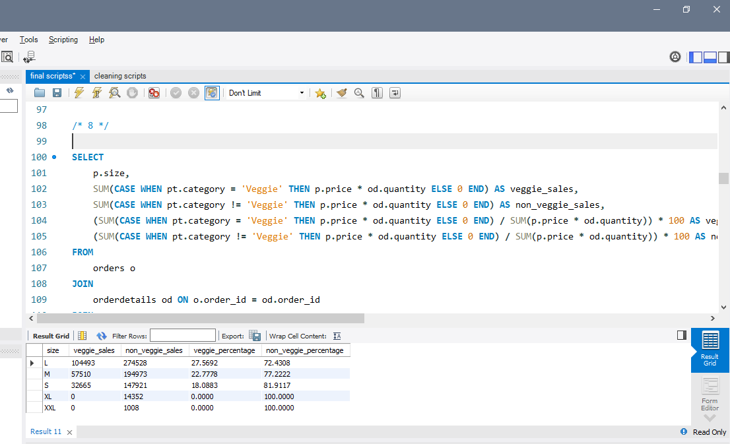

JOIN

orderdetails od ON o.order_id = od.order_id

JOIN

pizzas p ON od.pizza_id = p.pizza_id

JOIN

pizzatypes pt ON p.pizza_type_id = pt.pizza_type_id

GROUP BY

p.size

ORDER BY

p.size;

**9: Seasonal Trends:**

Identify seasonal sales patterns, allowing the shop to tailor marketing campaigns and promotions to capitalize on seasonal demand shifts.

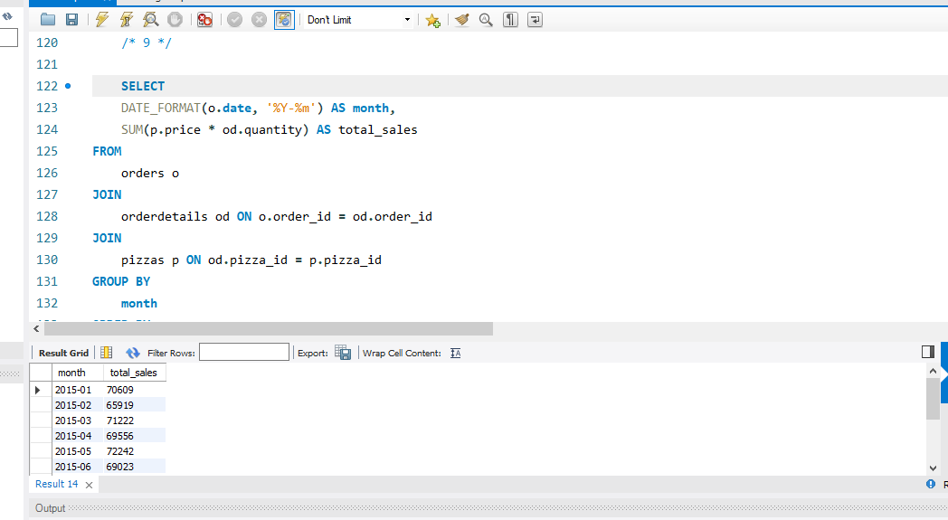

month

ORDER BY

month;

**10. Highest-selling pizza flavor**

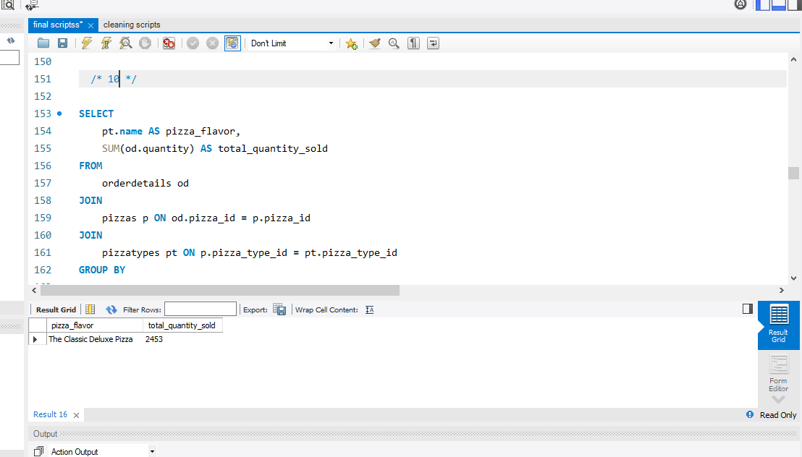

pt.name

ORDER BY

total_quantity_sold DESC

LIMIT 1;

**11. Similarities between the highest-selling and lowest-selling pizzas (Price, ingredients)**

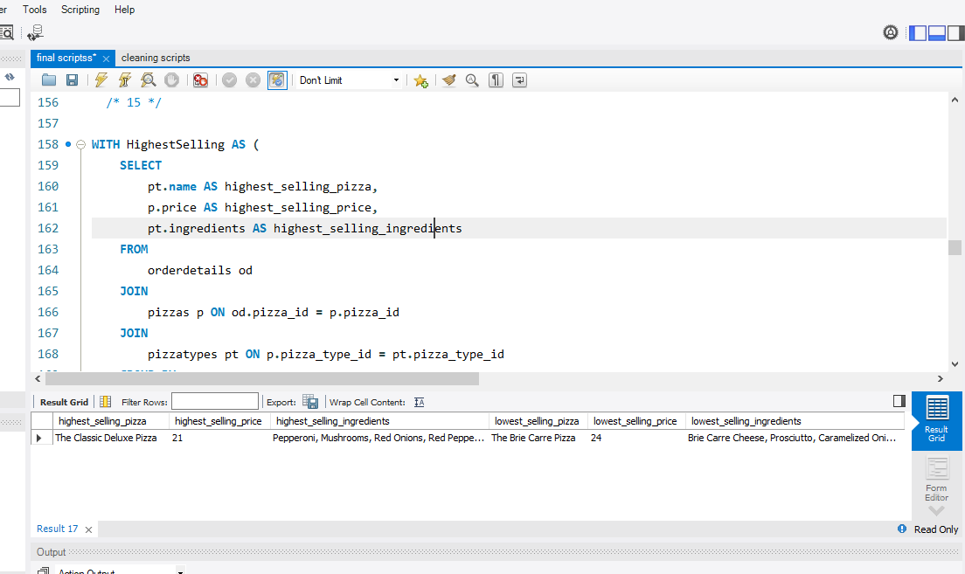

GROUP BY

pt.name

ORDER BY

SUM(od.quantity) DESC

LIMIT 1

),

LowestSelling AS (

SELECT

pt.name AS lowest_selling_pizza,

p.price AS lowest_selling_price,

pt.ingredients AS lowest_selling_ingredients

FROM

orderdetails od

JOIN

pizzas p ON od.pizza_id = p.pizza_id

JOIN

pizzatypes pt ON p.pizza_type_id = pt.pizza_type_id

GROUP BY

pt.name

ORDER BY

SUM(od.quantity) ASC

LIMIT 1

)

SELECT

H.highest_selling_pizza,

H.highest_selling_price,

H.highest_selling_ingredients,

L.lowest_selling_pizza,

L.lowest_selling_price,

L.lowest_selling_ingredients

FROM

HighestSelling H

CROSS JOIN

LowestSelling L;

**RESULT : 1**



**VISUALIZATION:1**

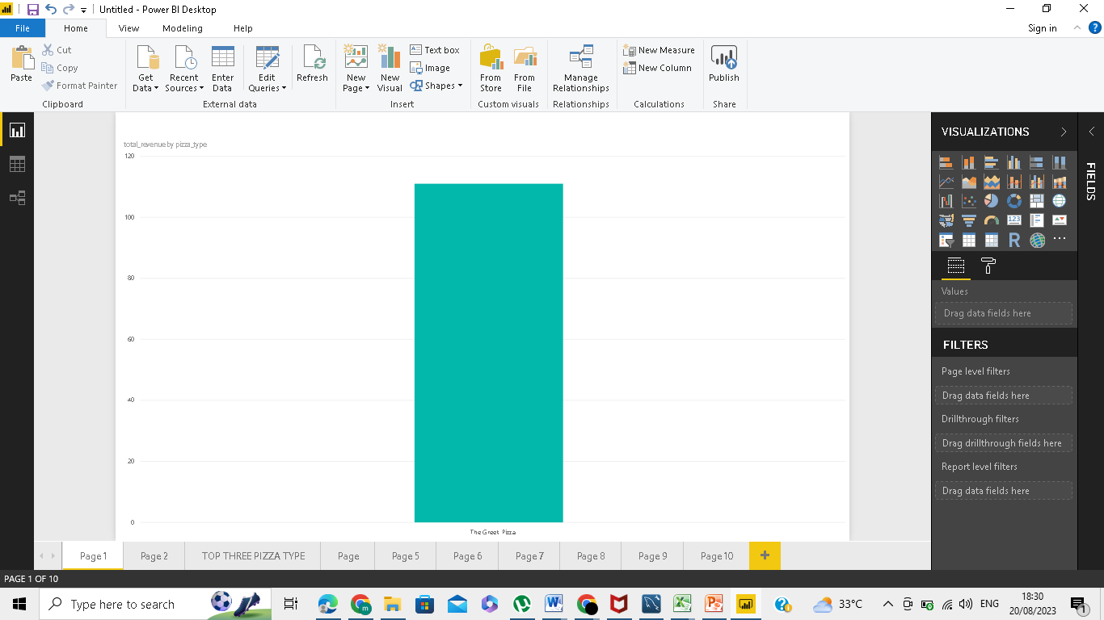

**INSIGHTS:**

The Greek Pizza has generated the highest revenue

**RESULT: 2**



**VISUALIZATION: 2**

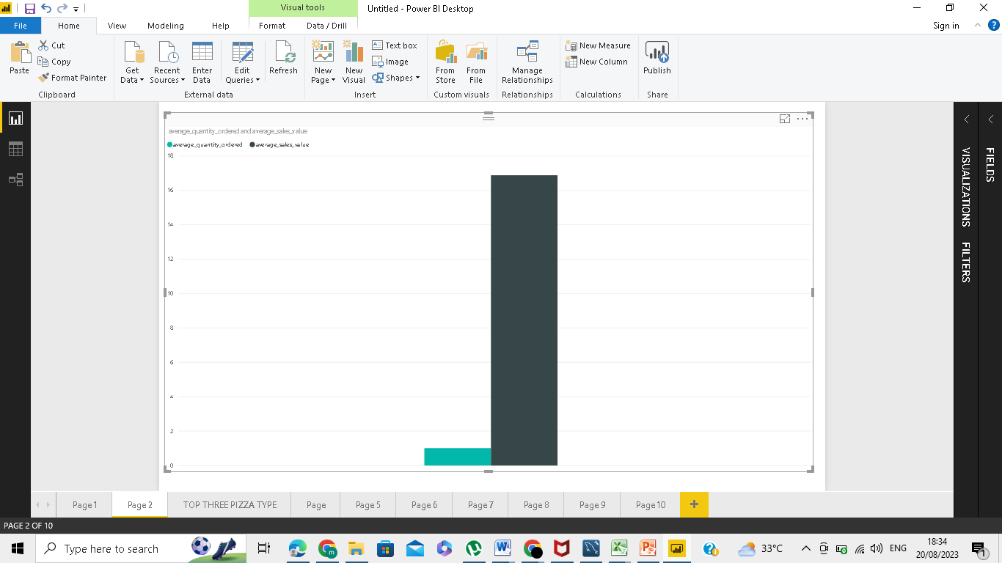

**RESULT:3**



**VISUALIZATION:3  
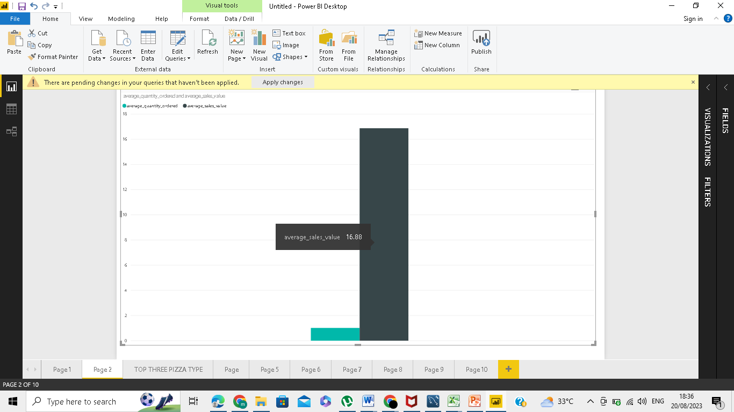**

**INSIGHTS**

**RESULT:4**



**VISUALIZATION:4**

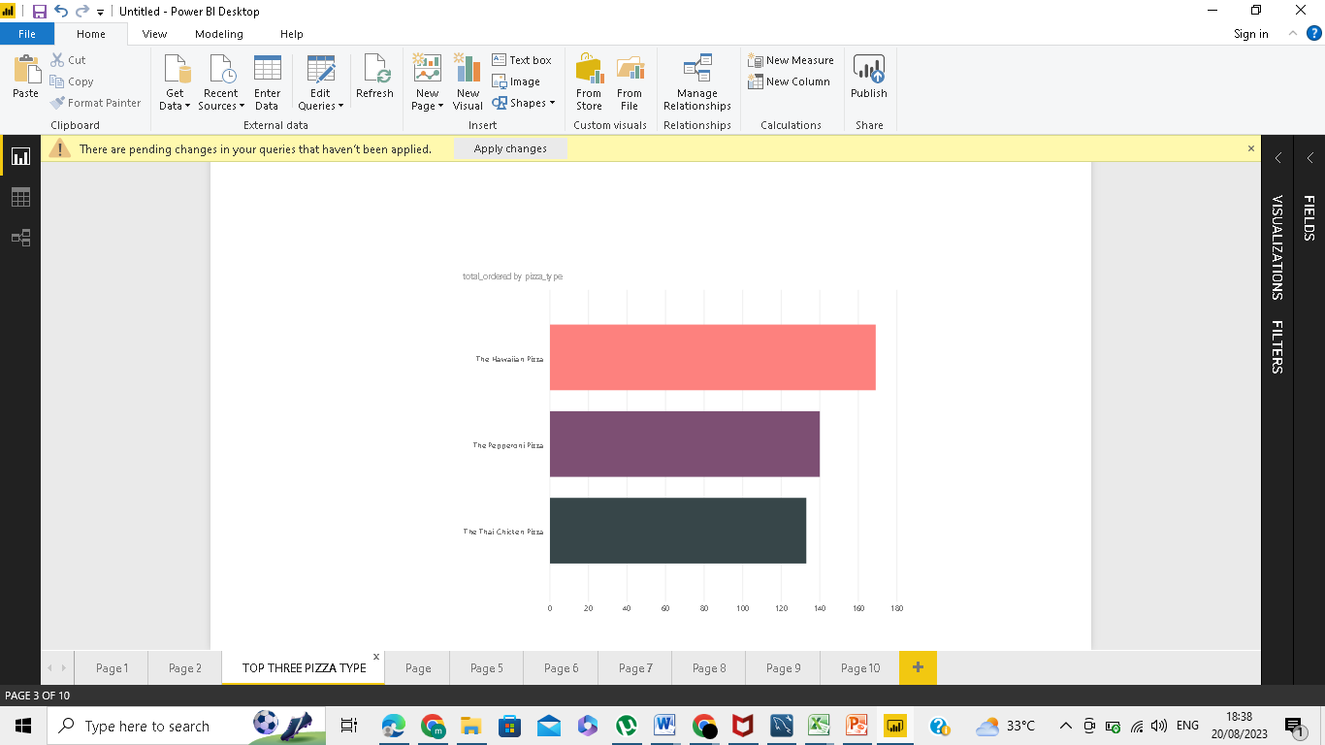

**INSIGHTS:**

**The hawaian pizza remaind the top most ordered pizza type, the pepperoni pizza at second while the thai chicken pizza as the third most ordered pizza type**

**RESULT:5**



**VISUALIZATION:5**

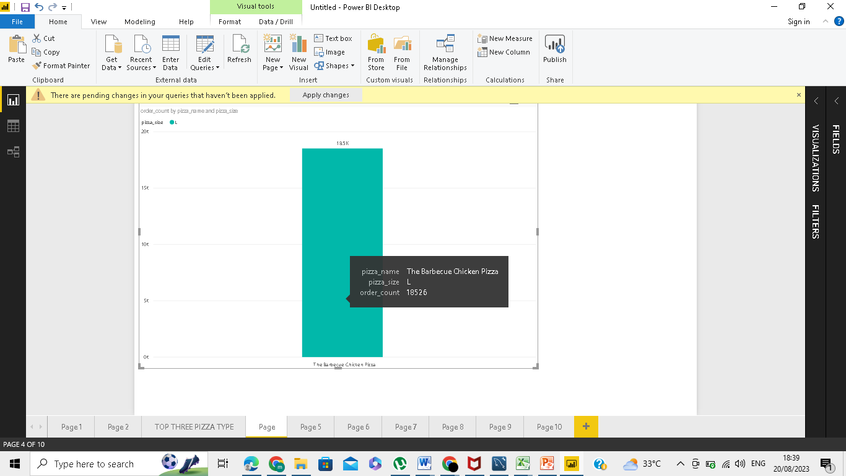

**INSIGHTS:**

**RESULT:6**



**VISUALIZATION:6**

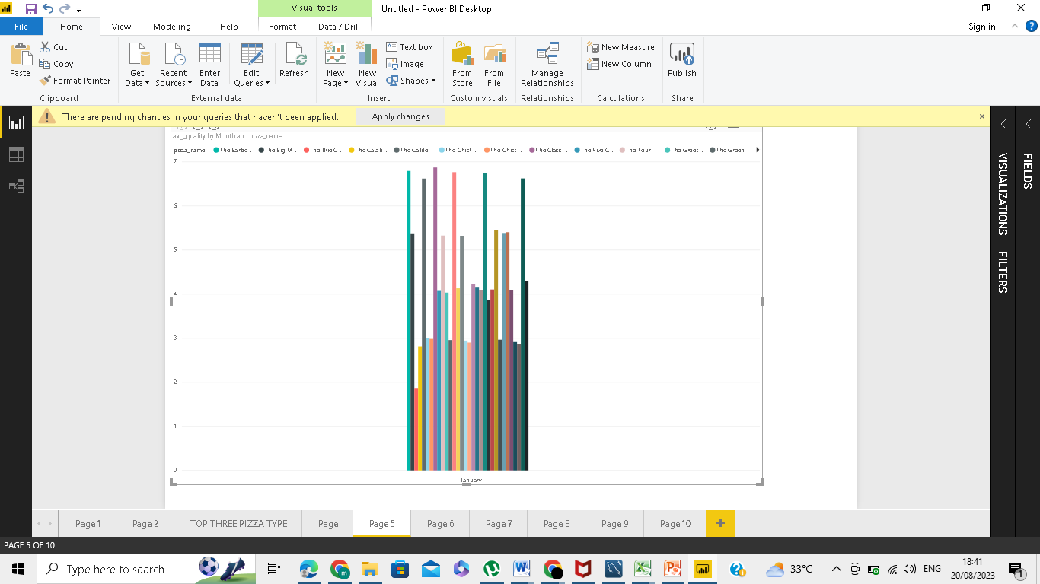

**INSIGHTS:**

**RESULT:7**



**VISUALIZATION:7**

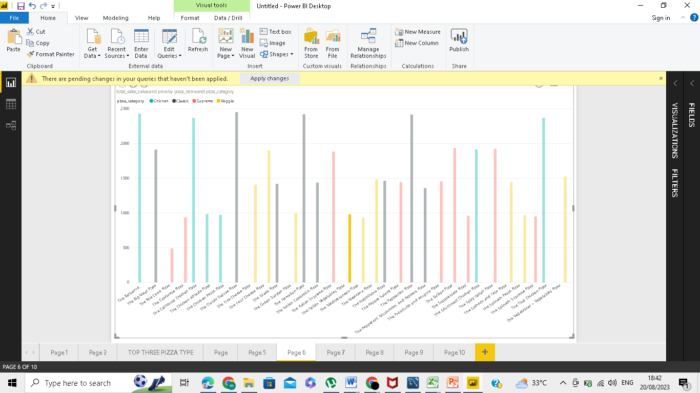

**INSIGHTS:**

**RESULT:8**

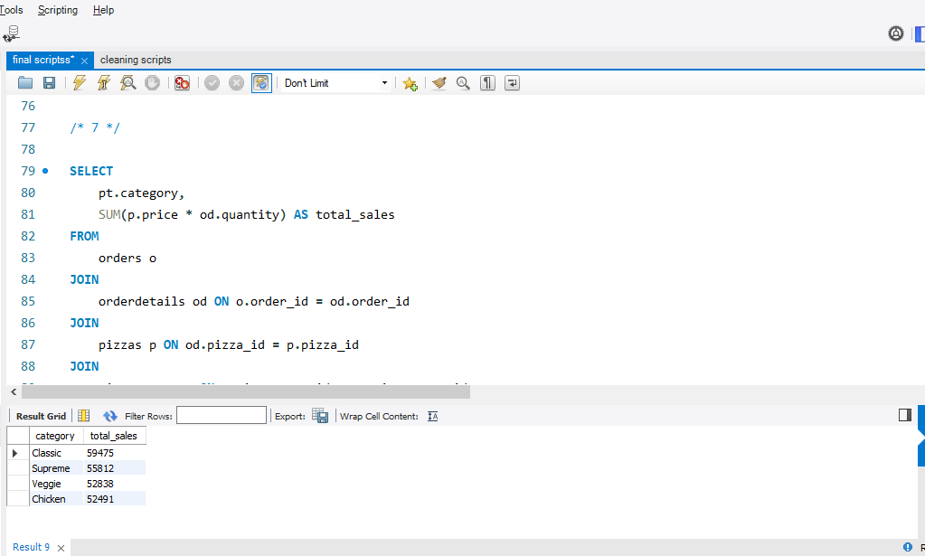

**VISUALIZATION:8**

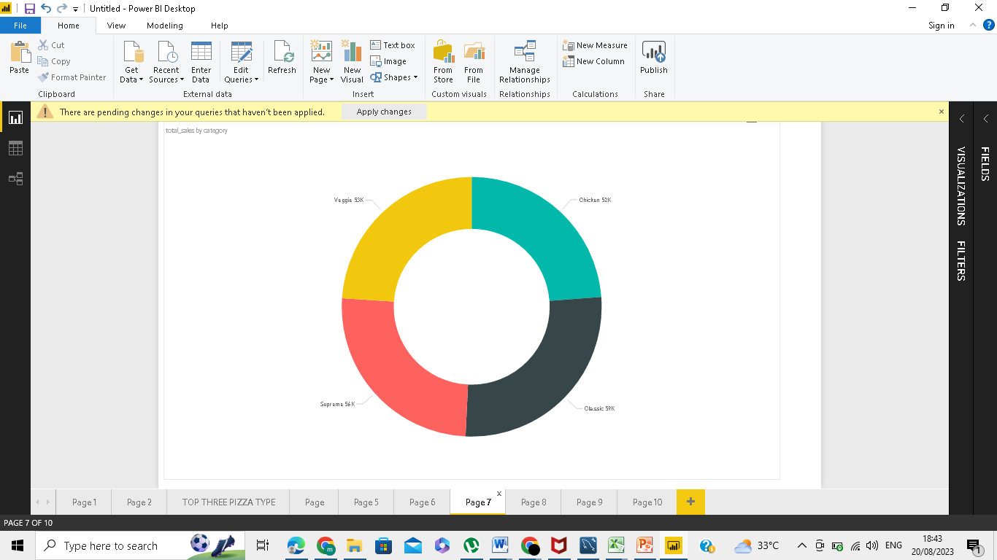

**INSIGHTS:**

Classic Category has the highest quantity sold of 59k while Chicken has sold the lowest quanity of 52,492

**RESULT: 9**



**VISUALIZATION: 9**

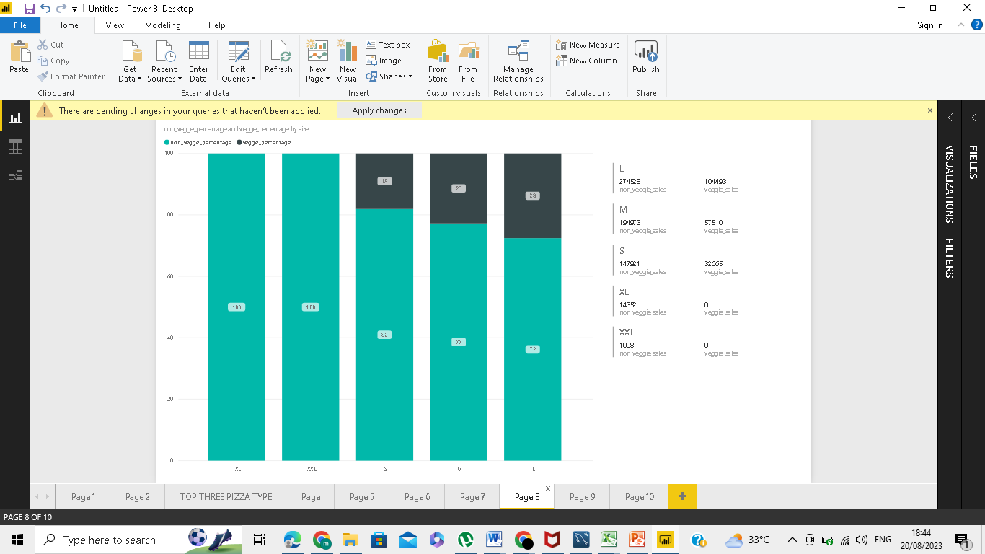

**INSIGHTS:** non-veg pizzas are sold mostly in small size with approximately 82 % where as veg pizzas are sold almost 18%. Similarly in medium size non-veg pizzas are sold higher with 77% and 23 % veg pizzas. Additionaly in large size non- veg pizzas are also sold higher with 72% and veg pizzas of 28%

On the other hand veg pizzas are sold 0 in both XL and XXL sizes

**RESULT: 10**



**VISUALIZATION: 10**

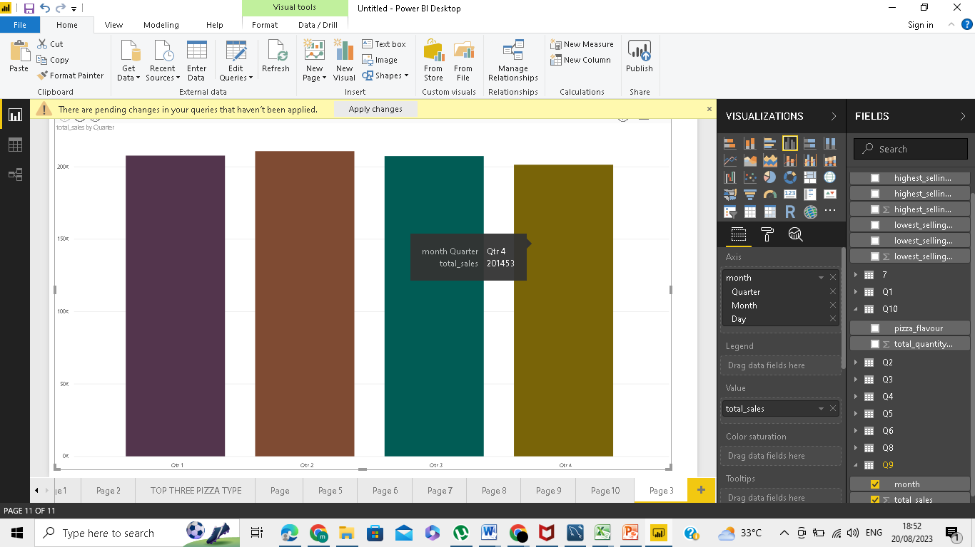

**INSIGHTS:**

**Quarter 2 which means from April to June, Pizza sales has remained the most compared to other quaters**

**RESULT: 11**



**VISUALIZATION: 11**

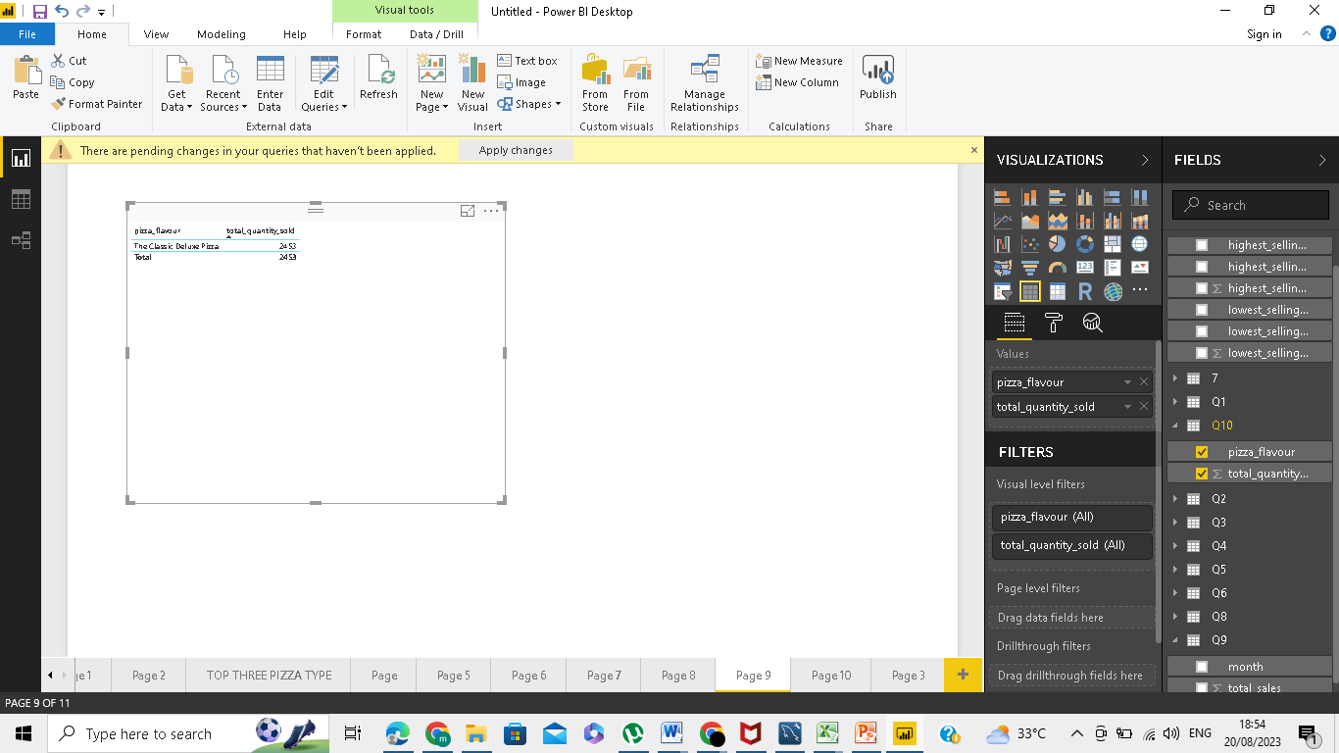

**INSIGHTS:**

Among all the pizza flavours The Classic Deluxe Pizza has the highest selling quantity 2454.